# Report on SOAP Web Service

Results

* Developed a SOAP Web Service
* Run "Webservice1.asmx" on Local Machine to test arithmetic operations Add, Subtract, Multiplication and Division
* URL: <http://localhost:59205/WebService1.asmx>
* User clicks on one of the four operations listed on the menu
* User can enter input values to perform basic four arithmetic operations
* Page displays with the output value in XML format

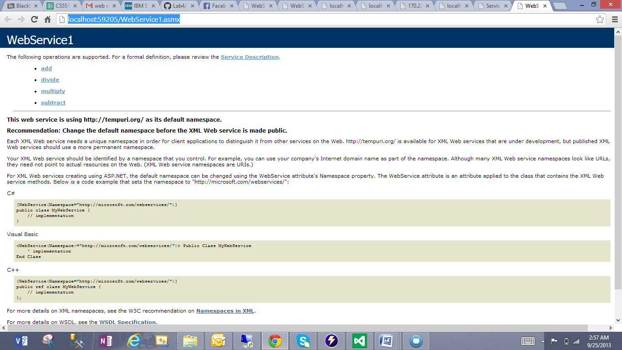

* Adding two numbers 123, 102

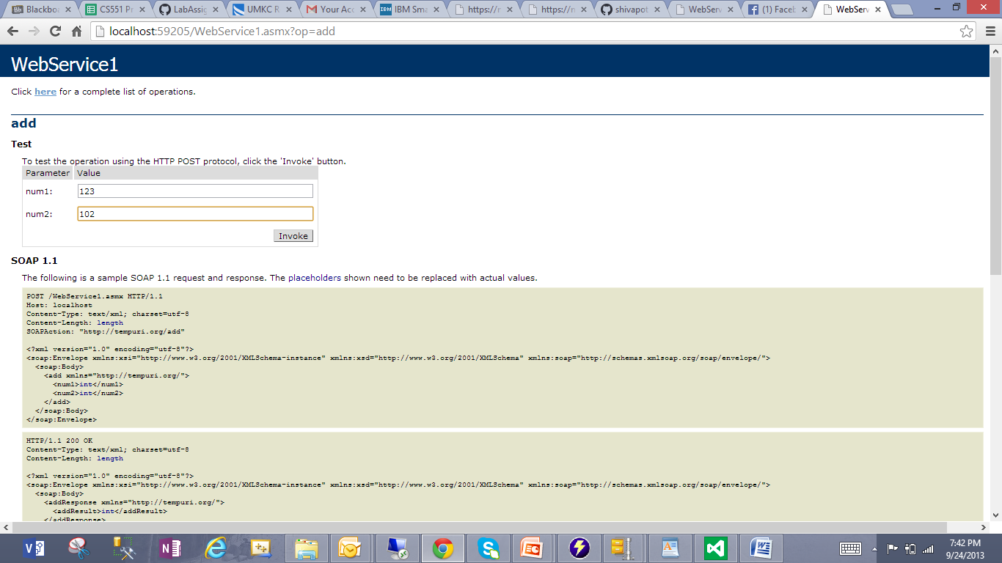

* Result shown 225 with data type integer in XML format

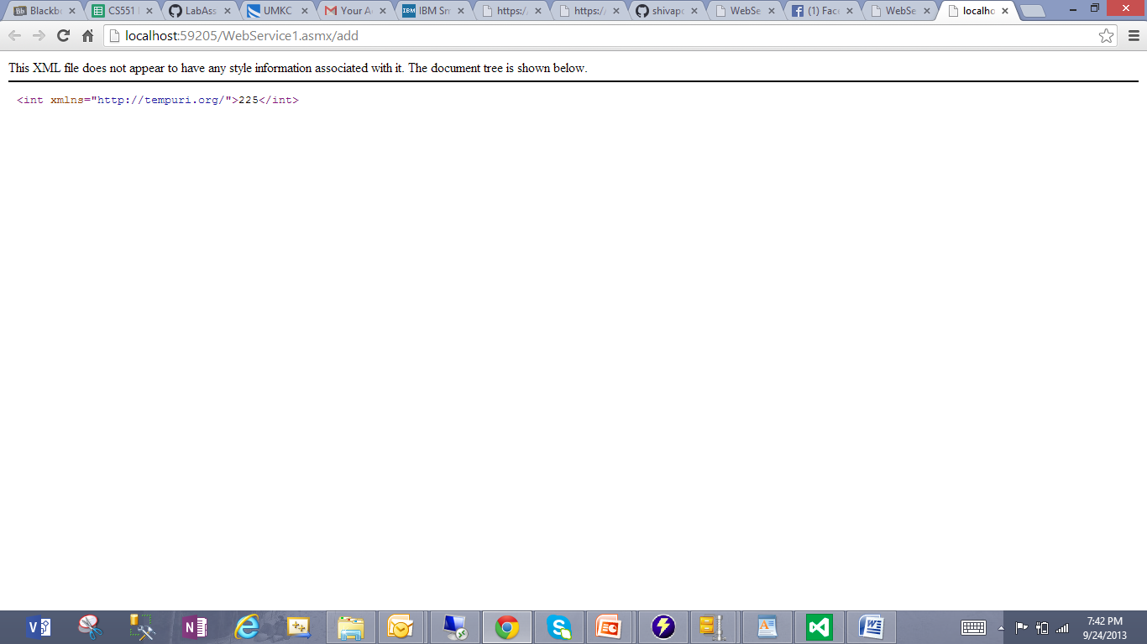

* Dividing two numbers 100, 5

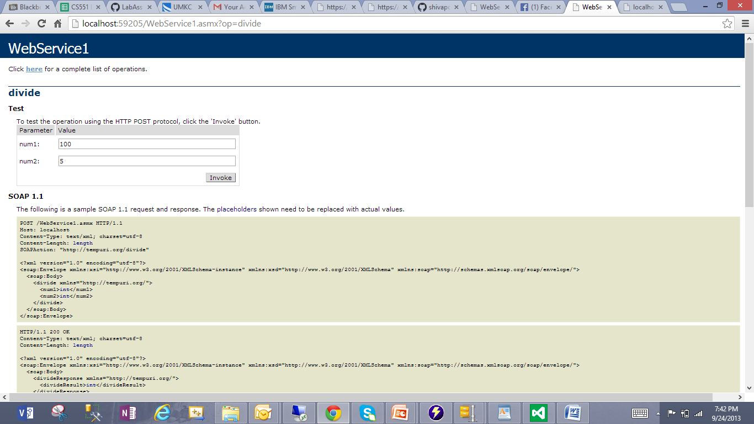

* Result shown 20

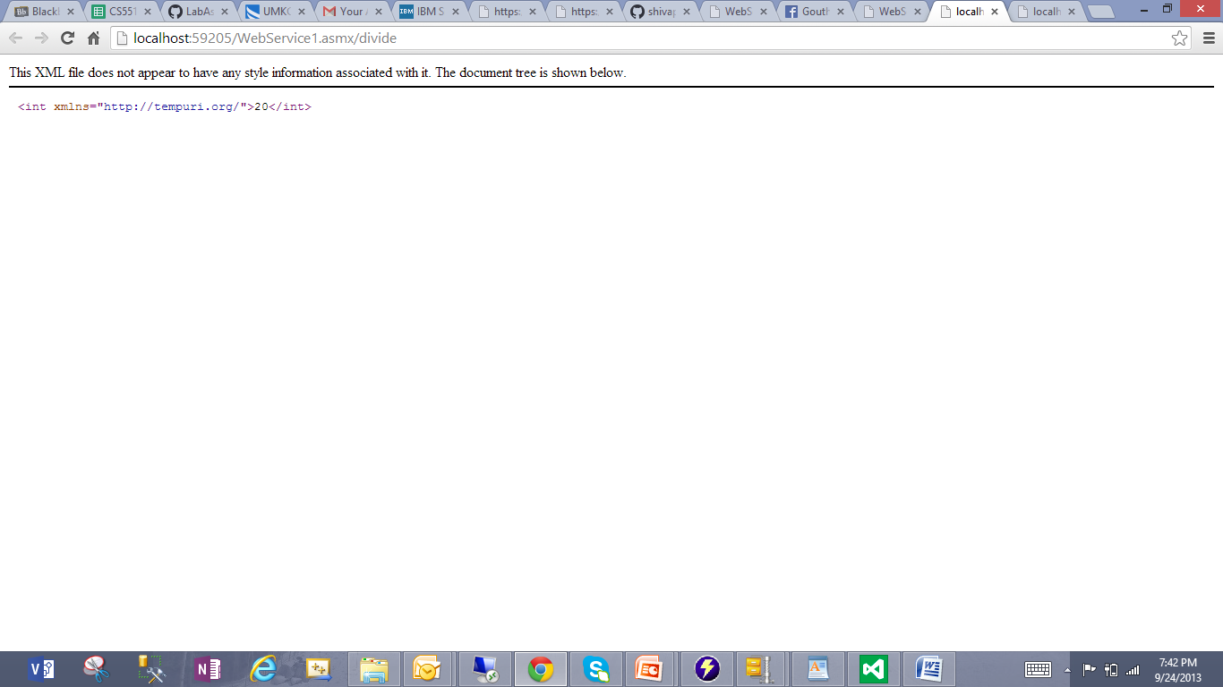

* Multiplying two numbers 10, 20

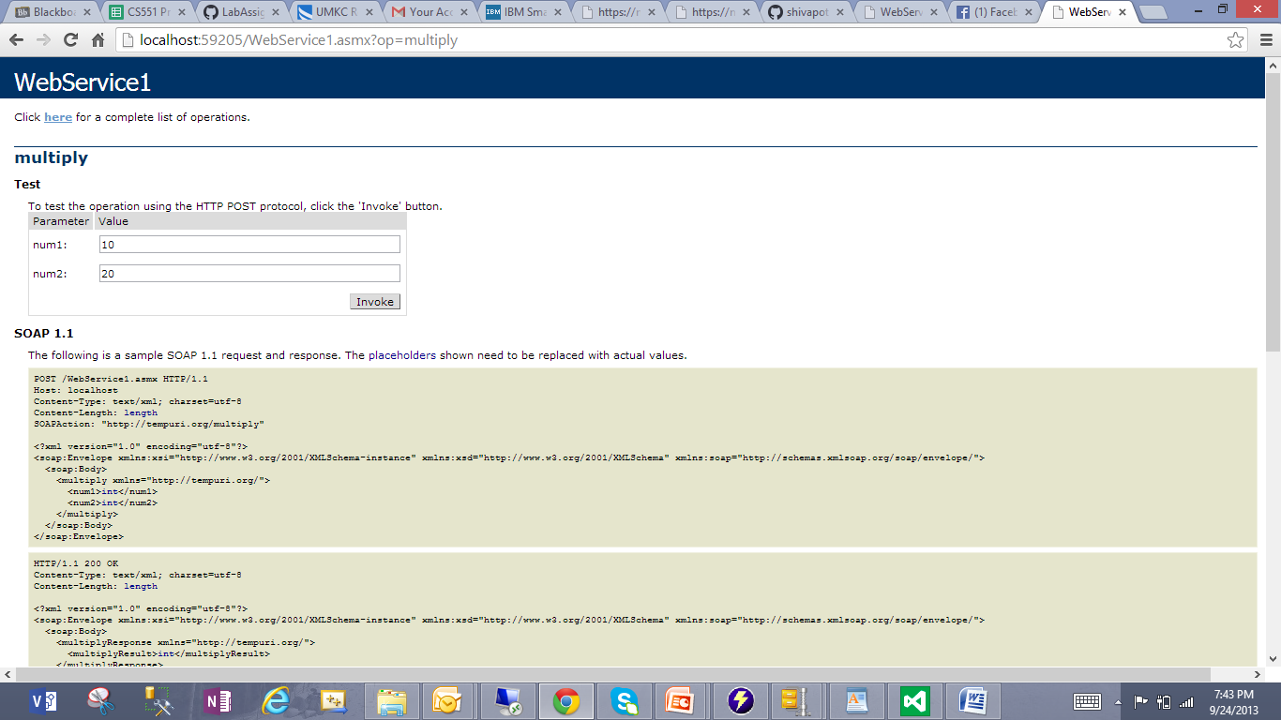

* Result shown 200

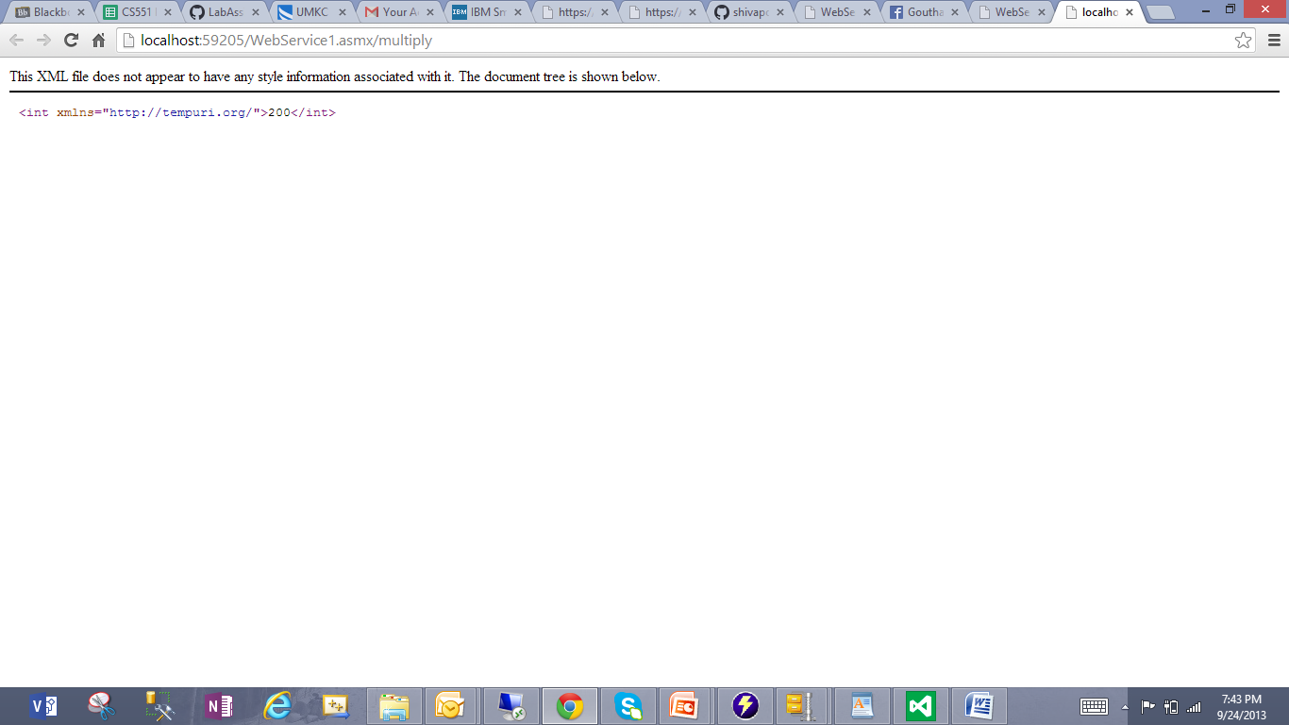

* Subtracting two numbers 3, 3

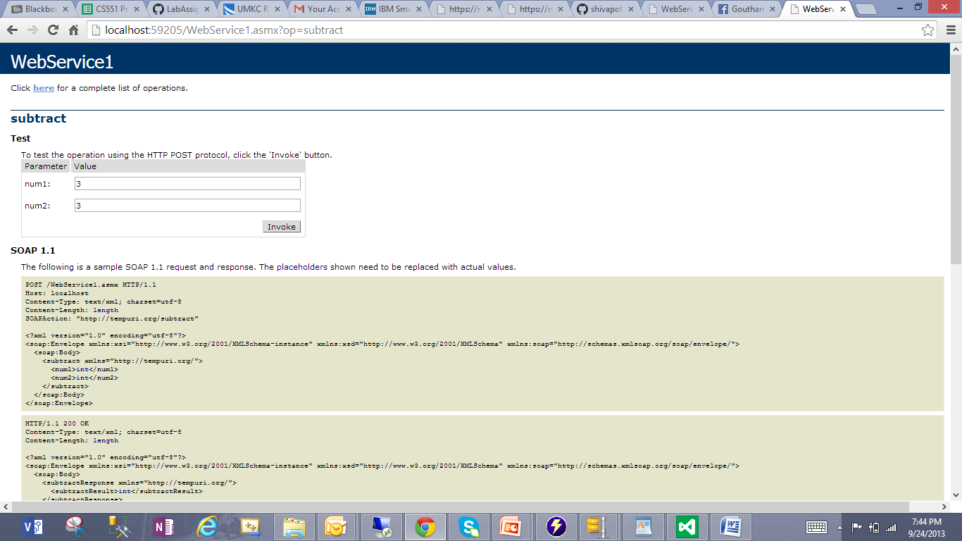

* Result shown zero

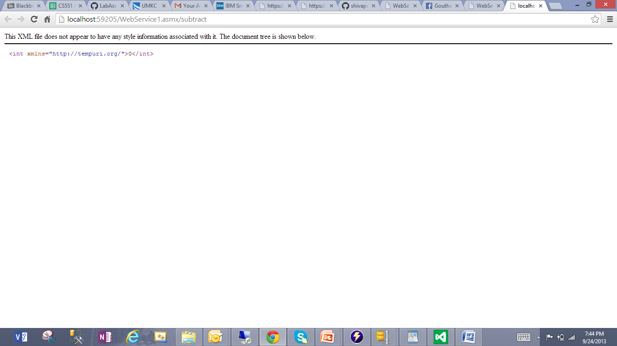

Deployed SOAP web service into IBM Cloud instance

URL: <http://localhost/aspnet_client/SoapWebService/WebService1.asmx>

* Browsed "Webservice1.asmx" to invoke on Remote Machine
* shows list of operations add, divide, multiply, subtract
* We can see WSDL code by clicking on Service Descriptions for each operation

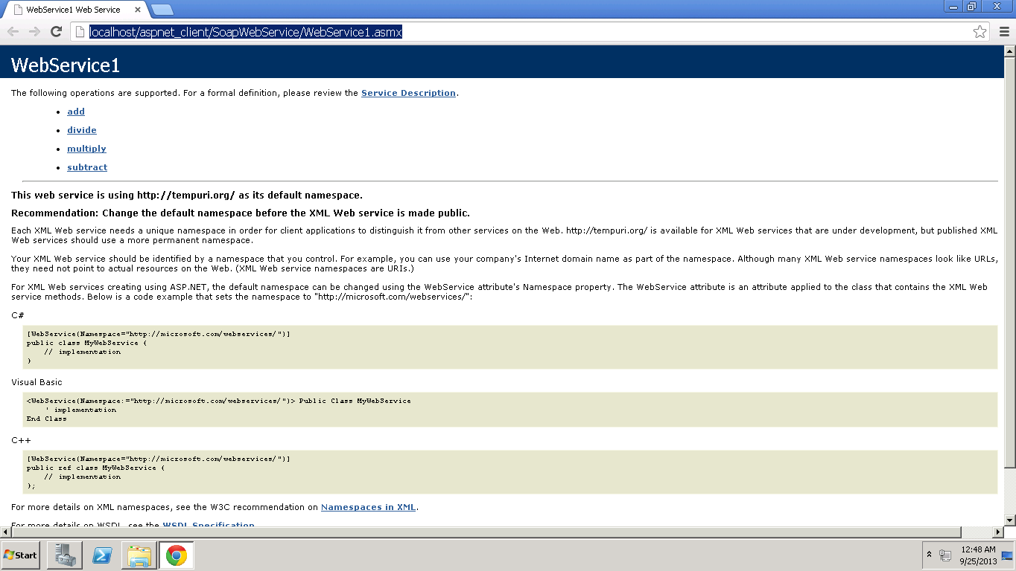

* Adding two numbers 10, 90

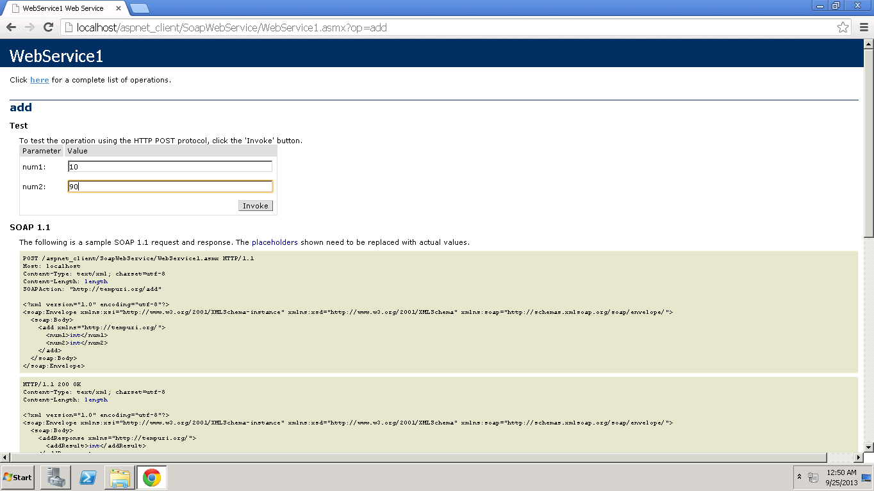

* After adding two numbers 10, 90 we can see the output 100 in the window displayed

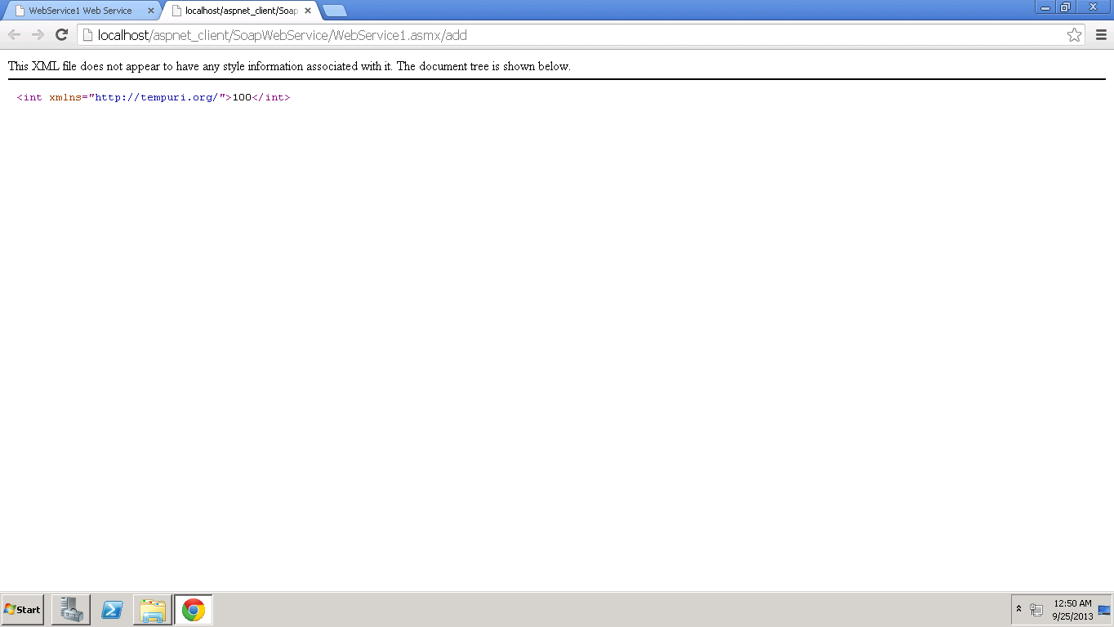

* Dividing two numbers 20, 20

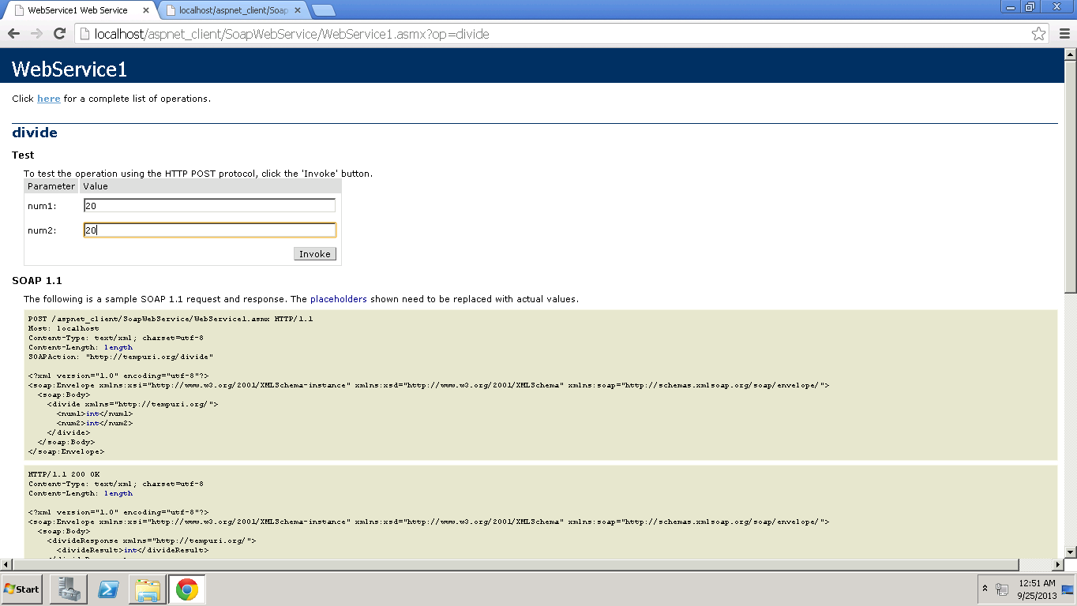

* Result shown 1

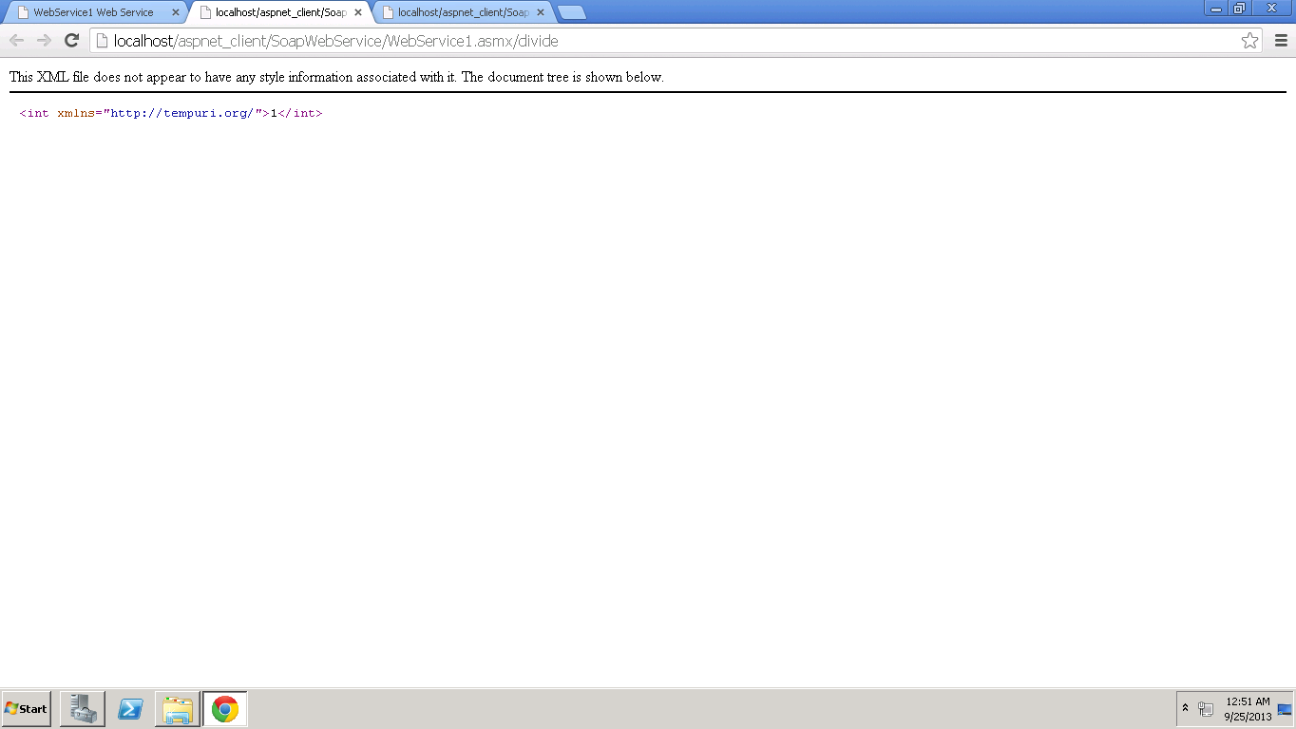

* Multiplying two numbers 1, 0

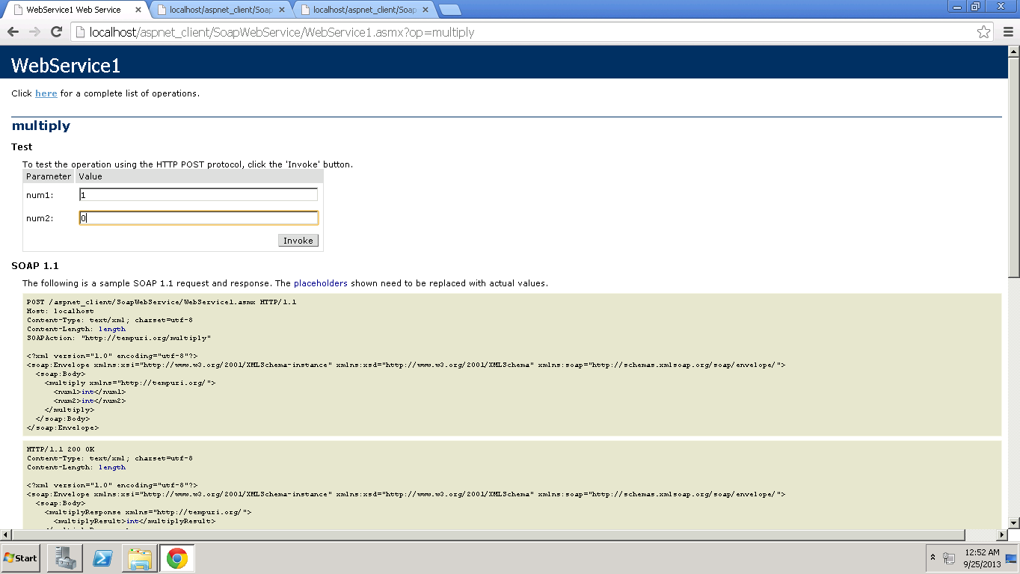

* Result shown 0

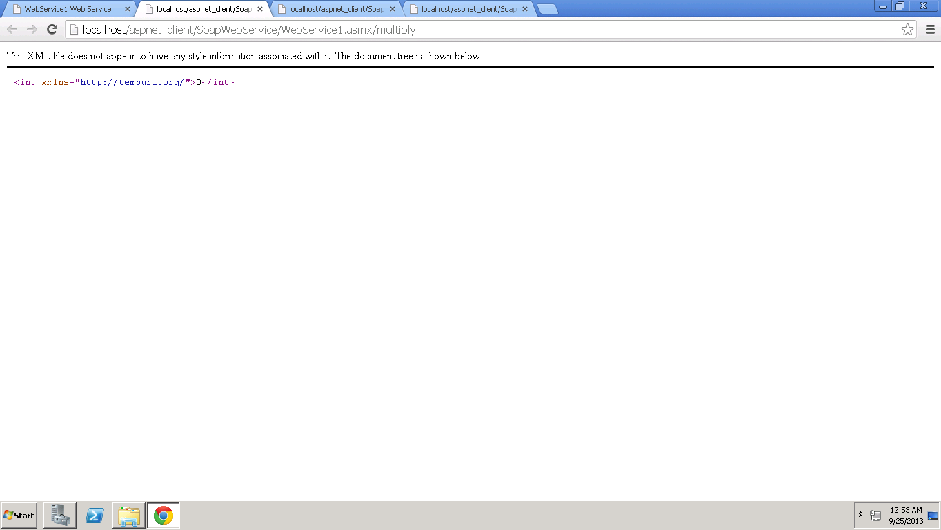

* Subtracting two numbers 100, 29

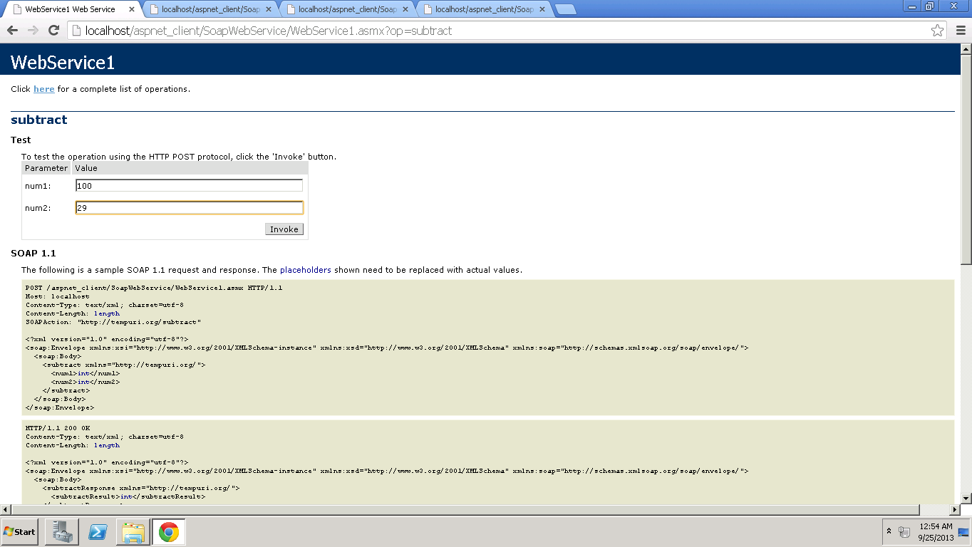

* Result shown 71

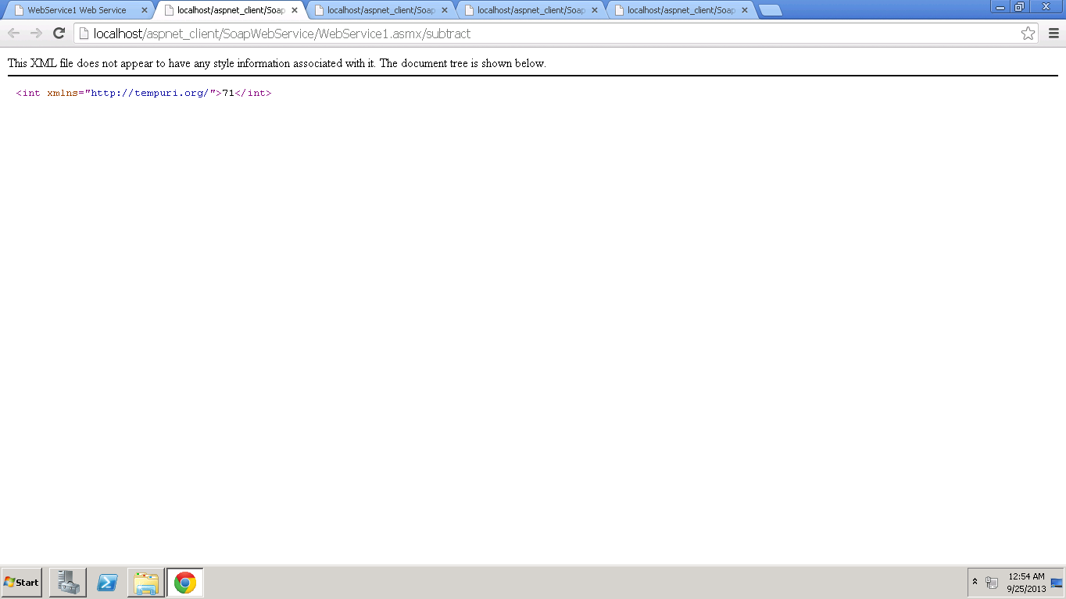

Accessing Remote SOAP web service from the Local Machine with my Cloud Instance IP Address 170.224.163.112

URL: <http://170.224.163.112/aspnet_client/SoapWebService/WebService1.asmx>

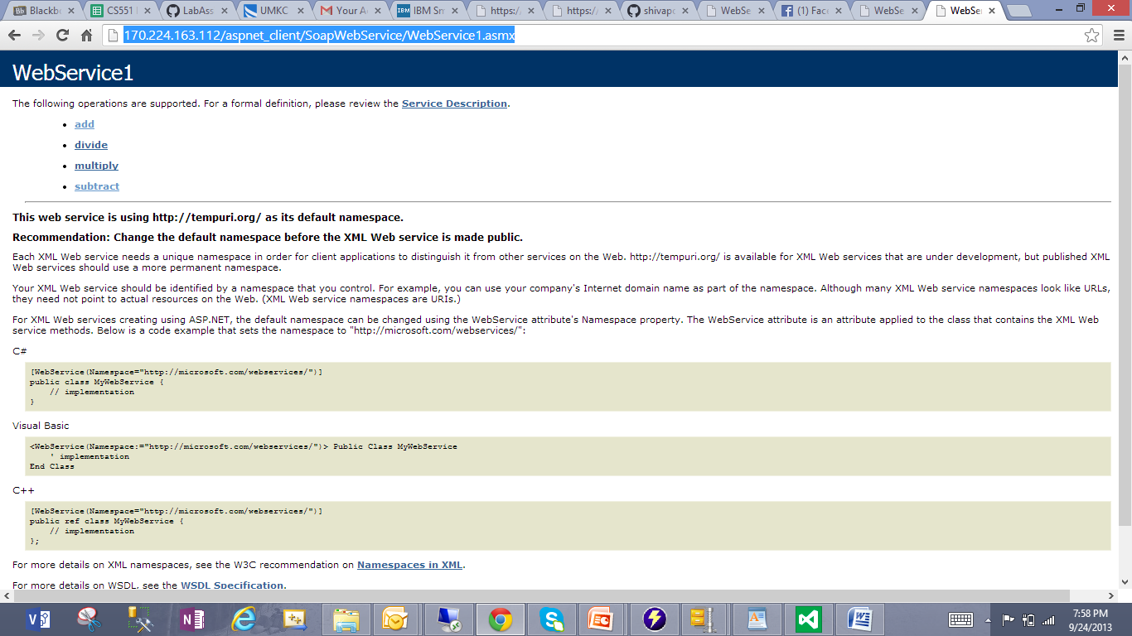

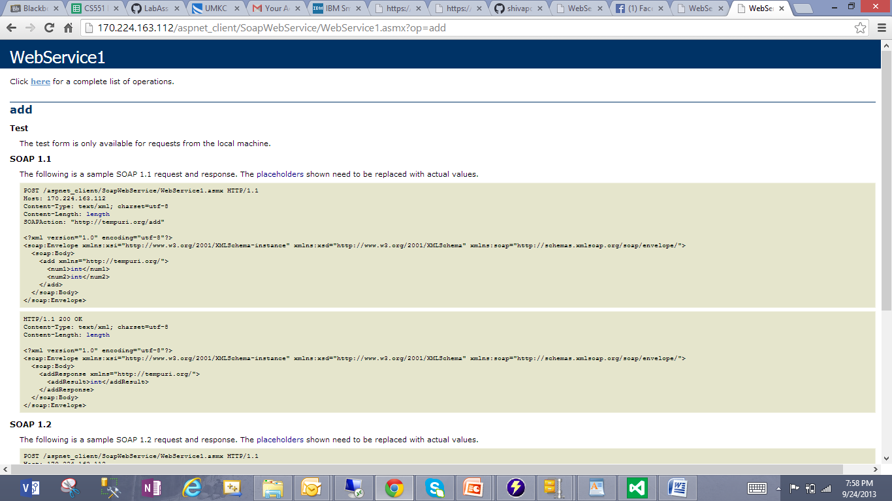

We can perform all operations like this.